1. INTRODUCTION

Overview:
In the modern sports industry, data-driven decision-making has transformed the way teams analyse, evaluate, and select players. Football, being one of the world’s most popular and competitive sports, now relies heavily on performance analytics to make strategic selections that maximize team potential. Traditional methods of selecting players often depend on a coach’s personal experience, observational judgment, and subjective evaluation. While such methods hold value, they can be influenced by personal bias, human error, and limitations in analyzing large volumes of performance data manually.
With advancements in Mobile Technology, Machine Learning, and Web-based Applications, it has become possible to automate and enhance the player evaluation process. Modern football clubs increasingly depend on digital platforms to track player statistics, analyze performance trends, and predict future capability. This shift highlights the growing importance of intelligent systems designed to support coaches and management in selecting the most suitable players for upcoming matches or tournaments.
The Android-Based Football Team Player Selection System developed in this project aims to address these challenges by introducing a smart and efficient way to evaluate and select football players based on predicted performance metrics. The system provides a unified digital platform where coaches, team managers, and selectors can analyze player attributes, monitor performance data, and make informed decisions backed by machine learning predictions. By relying on historical performance records and advanced analytics, the system enhances the reliability, accuracy, and fairness of the selection process.
At the core of the system is a Machine Learning–based Player Performance Prediction Model, implemented using Python. This model analyses various performance features such as goals, assists, passes, tackles, speed, stamina, and overall match contribution. Using algorithms such as regression or classification techniques, the system predicts each player’s expected performance rating. These predictions help decision-makers understand future potential rather than relying solely on past achievements.

The application consists of two major components: the Android Mobile App and the Web-Based Backend System.
The Android application, developed using Java and XML, provides an intuitive and user-friendly interface for coaches and selectors. Through the app, users can view player profiles, check predicted performance scores, compare players, and build an optimized team lineup. XML layouts ensure clean UI design, while Java handles the input validation, navigation, and communication with the backend server.
The backend is built using the Django Web Framework, which acts as a bridge between the Android app and the database. Django handles user authentication, request processing, data management, and communication with the machine learning model. The backend also includes an admin dashboard accessible through a web browser, giving administrators control over player records, performance data updates, and system maintenance.
MySQL is used as the central database for storing information such as player stats, match history, predicted scores, login credentials, and team selections. Its robust structure ensures secure data storage, efficient querying, and smooth integration with Django’s ORM (Object-Relational Mapping).
To enhance interactivity and responsiveness on the web dashboard, JavaScript is used for dynamic page updates, chart rendering, and asynchronous data handling. This ensures that coaches and admins can visualize performance information clearly through graphs, tables, and real-time analytics.
By integrating Android, Python-based machine learning, Django, MySQL, JavaScript, and XML, the system achieves a reliable, scalable, and technologically advanced solution. It automates player assessment, reduces human bias, accelerates the selection process, and ensures that only the most capable players are chosen for the team based on objective data insights. To ensure smooth functioning and proper role management, the system incorporates two main user roles Admin and Coach—each having distinct responsibilities and permissions. The admin is responsible for managing the core data within the system and has complete authority over player-related information. The admin can add new players, update or modify player skills, and view all existing team players and their records. However, the Admin does not have access to the performance prediction feature, as the system reserves analytical and strategic decision-making exclusively for the Coach.

The Coach, on the other hand, uses the system primarily for evaluating and selecting players based on their capabilities. The Coach can add or update player skills, view team players, and analyze their performance attributes. Most importantly, the Coach has access to the machine learning–based performance prediction feature, enabling them to generate predictions and make informed team selection decisions. The Coach cannot add new players to the system, ensuring that player registration and data integrity remain under the admin’s control. This clear separation of roles ensures both effective management and reliable analytical decision-making within the platform.
Overall, the Android-Based Football Player Selection System Using Machine Learning represents a significant step toward modernizing the sports selection process. It combines the power of predictive analytics with mobile accessibility, ensuring that coaches and management can make smarter and more efficient decisions. This digital transformation not only improves team formation and performance but also promotes transparency, fairness, and strategic planning in the ever-evolving world of football.

Objectives:
The main objectives of the proposed system are:
    - To develop an intelligent, data-driven platform that assists coaches in selecting suitable football players based on predicted performance metrics.
    - To replace traditional subjective evaluation methods with a more analytical and automated decision-making process.
    - To implement a machine learning model that predicts player performance using historical data and key performance indicators.
    - To create a role-based system where Admins and Coaches have separate permissions for secure and organized data management.
    - To provide a user-friendly Android application that enables coaches to view players, analyze data, and generate performance predictions.
    - To ensure efficient storage, retrieval, and management of player information using a robust MySQL database integrated with Django.

Problem of Statement:
In football team management, selecting the right players for a match or tournament is a critical task that directly influences team performance and overall success. Traditionally, player selection is carried out based on the coach’s personal judgment, observational experience, and subjective evaluation methods. While these techniques are valuable, they often suffer from limitations such as human bias, inconsistent assessment, lack of accurate performance comparison, and the inability to manually analyze large volumes of player data. As modern football increasingly demands data-driven decision-making, existing manual processes fail to provide the level of accuracy, objectivity, and efficiency required for optimal team formation.
Additionally, many football selections lack a centralized system to manage player records, skill attributes, and past performance metrics. Coaches and administrators struggle to maintain updated data, evaluate players consistently, and make informed decisions. The absence of automated performance prediction tools further restricts the ability to forecast player readiness and potential contribution in upcoming matches.
Therefore, there is a clear need for an intelligent, automated system that can store player information, analyze performance statistics, predict future performance using machine learning, and support role-based access for Admins and Coaches. Such a system should streamline player management, reduce human error, improve accuracy, and provide objective insights to aid in selecting the most suitable players.

Motivation:
The growing influence of technology in sports has created a strong need for systems that support data-driven decision-making, especially in player analysis and team formation. In football, where performance can vary widely from player to player and match to match, relying solely on traditional observation-based selection often leads to inconsistent outcomes. This challenge motivates the development of an intelligent platform that can objectively analyze player data and predict performance using machine learning.
The motivation behind this project arises from the need to minimize human bias, improve accuracy in player evaluation, and enhance the fairness of the selection process. Modern football teams increasingly depend on digital tools for maintaining records, assessing skills, and understanding player strengths. However, the absence of a unified system that integrates both data management and predictive analytics creates a significant gap in decision support for coaches and administrators.
Furthermore, smartphones have become a primary medium for accessing information conveniently and quickly. This encourages the development of an Android-based application that allows coaches to easily assess players, view performance statistics, and generate predictions anytime and anywhere. The combination of Android mobility, Django backend processing, MySQL database storage, and Python-based machine learning provides a powerful and practical solution to the limitations in existing selection methods.
Ultimately, this project is motivated by the goal of helping football teams make smarter, faster, and more reliable decisions. By providing accurate predictions and organized data management, the system aims to support both coaches and admins in building stronger, better-performing teams while embracing modern technological advancements.

Advantages of the System

The proposed system offers several advantages:
    - Fast Selection Process: The system quickly selects players based on their performance data, saving time compared to manual selection.
    - Fair and Unbiased: Players are chosen based on real statistics, removing human bias from the selection process.
    - Easy to Use: Coaches and managers can easily enter data and get results without technical skills.
    - Accurate Player Evaluation: The system analyzes player performance correctly, leading to better team decisions.
    - Better Team Performance: By selecting the best players, the overall team strength improves.
    - Data Storage and Management: All player details and performance records are stored safely for future use.
    - Reduces Human Error: Automated calculations avoid mistakes that can happen in manual selection.
    - Improves Transparency: Coaches and players can clearly see why a player was selected or not, increasing trust.

Challenges:

While Collaborative Filtering is effective, it faces several challenges that must be addressed for optimal performance:
    - Data Accuracy Needed: The system works only if the player data entered is correct. Wrong data leads to wrong selection.
    - Technical Issues: Software bugs, slow performance, or system crashes can affect the selection process.
    - Limited Flexibility: The system may not handle unexpected situations like injuries or sudden changes in team strategy.
    - Requires Initial Training: Coaches or staff may need time to learn how to use the system properly.

Applications:

The Android based Football Team Player selection by Player Performance Prediction Recommendation System has a wide range of practical applications, including:
  - Team Formation: Helps coaches automatically select the best players for a match.
  - Player Performance Tracking: Keeps records of each player’s skills, fitness, and match performance.
  - Training Management: Assists in planning practice sessions based on players’ strengths and weaknesses.
  - Tournament Preparation: Useful for selecting squads for school, college, club, or district-level tournaments.
  - Injury & Fitness Monitoring: Tracks health status and avoids selecting unfit or injured players.
  - Performance Analytics: Generates reports and analytics to improve team strategies.
  - Decision Support for Coaches: Provides data-based suggestions to help coaches make fair selection decisions.
  - Record Maintenance: Stores long-term data on players, matches, and teams for future use.

2. LITERATURE REVIEW
1. M. Bialik et al. (2016) explored the use of machine learning models such as Random Forest and Logistic Regression to predict football player performance.
M. Bialik et al. (2016) conducted a significant study focused on predicting football player performance using machine learning techniques. The researchers employed models such as Random Forest and Logistic Regression to analyze historical performance data and generate predictions about player ratings. Their approach demonstrated that machine learning could effectively identify patterns in past matches and use these insights to evaluate how players might perform in future games.
The study highlighted the importance of data-driven decision-making in modern sports analytics. By training the models on features such as player statistics, match outcomes, and historical gameplay attributes, the authors were able to achieve promising accuracy in forecasting player performance. This proved that machine learning could be a powerful tool for enhancing player evaluation and supporting analytical tasks in football management.
However, the study also had certain limitations. While the models showed good predictive capability, the research did not incorporate the results into a real-time or mobile-based system, which restricts practical use for coaches, managers, and team analysts. Moreover, the study focused solely on prediction and did not explore its application in tasks like team selection or performance improvement strategies.

2. R. Gudmundsson and S. Horton (2017) conducted a comprehensive spatio-temporal analysis of football events, applying data mining techniques to event-based datasets.
R. Gudmundsson and S. Horton (2017) carried out an extensive study focusing on the spatio-temporal analysis of football events, utilizing advanced data mining techniques on event-based datasets. Their work emphasized understanding how players move, interact, and contribute within the game by analyzing spatial positions and temporal sequences of actions. This approach allowed them to capture meaningful patterns related to player behavior, teamwork, coordination, and match flow.The researchers demonstrated how combining spatial (location-based) and temporal (time-based) information can reveal hidden insights into player performance and game dynamics. Their methodology helped identify patterns such as movement strategies, passing choices, positional strengths, and tactical formations adopted during matches.
This form of analysis is particularly useful in modern football analytics, where understanding player positioning and movement plays a key role in assessing their overall impact.
While the study offered valuable insights into performance assessment, it had notable limitations. The research primarily focused on analyzing patterns and behaviours, rather than predicting future performance or assisting in automated team selection. Additionally, the study did not integrate machine learning models for forecasting player potential, nor did it propose practical solutions suitable for implementation in real-time or mobile applications.

3. D. Decroos et al. (2019) introduced the VAEP (Valuing Actions by Estimating Probabilities) framework.
D. Decroos et al. (2019) introduced the VAEP (Valuing Actions by Estimating Probabilities) framework, a novel approach for evaluating football player performance by assessing the impact of every individual action on the overall game outcome. Unlike traditional metrics that focus primarily on goals or assists, the VAEP framework assigns value to all on-ball actions, such as passes, dribbles, tackles, and positioning, based on how they change the probability of scoring or conceding a goal. This provides a more comprehensive and nuanced understanding of a player’s contribution during a match.
The framework employs supervised learning techniques to model and quantify these actions, enabling teams to analyze players in terms of their influence on game dynamics rather than just raw statistics. This allows coaches and analysts to identify high-impact players who may not necessarily be the top scorers but significantly contribute to the team’s success through their actions.
While the VAEP framework represents a significant advancement in football analytics, it also has some limitations. The computation of action values is computationally intensive, requiring substantial processing power, which can make real-time or mobile application integration challenging. Furthermore, the system is heavily data-dependent, meaning its accuracy relies on the availability of high-quality, detailed match data.

4. Y. Lucey et al. (2014) introduced advanced concepts related to player tracking, passing networks, and positional dynamics within football.
Y. Lucey et al. (2014) conducted a seminal study focusing on player tracking, passing networks, and positional dynamics in football, providing a framework to analyze team strategies and individual contributions on the field. Their research leveraged detailed tracking data to model player movements, ball possession, and passing interactions, enabling a comprehensive understanding of team behaviour and tactical patterns. By mapping passing networks and positional changes over time, the study demonstrated how a player’s movement and decision-making impact overall team performance.
The methodology highlighted the importance of spatial-temporal analysis for assessing player roles, positioning efficiency, and coordination with teammates. These insights offered coaches and analysts the ability to quantify tactical contributions and evaluate performance beyond traditional statistics like goals or assists. The research contributed significantly to the development of analytics tools that can inform strategy, optimize formations, and support performance evaluation in professional football.
However, the study had some limitations. While it provided deep insights into tactical and positional analysis, it did not focus on predicting individual player performance or assisting in automated team selection. The work was primarily aimed at understanding game dynamics and optimizing strategies rather than providing actionable recommendations for player selection.

5. A. Groll et al. (2018) proposed the use of Poisson regression and Random Forest models to predict football match outcomes.
A. Groll et al. (2018) conducted a study aimed at predicting football match outcomes using statistical and machine learning models, specifically Poisson regression and Random Forest algorithms. Their approach utilized historical match data, including team statistics, past results, and contextual factors, to estimate the probability of various match outcomes such as wins, draws, or losses. By combining traditional statistical modelling with modern machine learning techniques, the researchers were able to improve prediction accuracy and provide valuable insights into match-level performance trends.

The study demonstrated that machine learning models could successfully analyze complex historical data and account for multiple influencing factors to forecast match results. This offered a significant advancement in sports analytics, as it allowed for more objective, data-driven assessments of upcoming matches compared to relying solely on expert intuition or experience.However, the study had notable limitations in the context of player evaluation and team formation. The models were focused at the match level, meaning they analyzed overall team performance rather than predicting individual player performance. As a result, while the research is valuable for betting, match outcome forecasting, and tactical planning, it does not directly support automated player selection or performance prediction for individual athletes.Overall, the work of Groll et al. contributes to the field of football analytics by illustrating the effectiveness of combining statistical and machine learning models for outcome prediction. It serves as a foundation for future research that could extend similar methodologies to individual player performance forecasting and team selection applications.

6. Sharma and Verma (2021) applied data analytics techniques such as K-Means clustering and Decision Trees to assist in football player selection.
Sharma and Verma (2021) conducted a study focusing on football player selection using data analytics techniques such as K-Means clustering and Decision Trees. Their approach aimed to group players based on performance metrics, skills, and positional roles, allowing coaches to make informed decisions about team formation. By clustering players with similar characteristics and analyzing their statistical attributes, the system provided a structured method for selecting players who best fit the tactical requirements of the team.
The use of Decision Trees enabled the researchers to identify key performance factors that influence player selection, offering a clear decision-making framework that coaches could rely upon. This combination of clustering and rule-based analysis helped in creating balanced teams, optimizing player roles, and ensuring that player skills aligned with team strategies. However, the system had certain limitations. The user interface was limited, making it less accessible for coaches and team managers, and the study did not provide support for mobile applications, which restricts on-the-go access to player data and selection recommendations.

3. SOFTWARE AND HARDWARE REQUIREMENT
3.1 SOFTWARE REQUIREMENT
- Operating System : Windows 7 or above/ Linux
- Web Server : Django
- Programming Languages : Python, JS, Java, XML
- Web browsers : Google chrome/Mozilla Firefox/internet explorer
- Database : MYSQL
- IDE : Visual studio code, Android Studio

3.2 HARDWARE REQUIREMENTS
- Processor :1 GHZ or higher CPU
- Hard disk : 500 MB available internal storage
- Memory : 8 GB of RAM is minimally recommended
- Display : 2.8 inches or larger

4. METHODOLOGY AND SYSTEM DESIGN
4.1 Overview of the Methodology:
The methodology for “Android based Football team player selection by player performance prediction” involves developing a data-driven Android application that predicts player performance and assists in selecting the most suitable football team. The approach integrates machine learning techniques with mobile development to ensure efficient and accurate team formation based on historical player data and current form.

4.2 System Architecture Diagram:
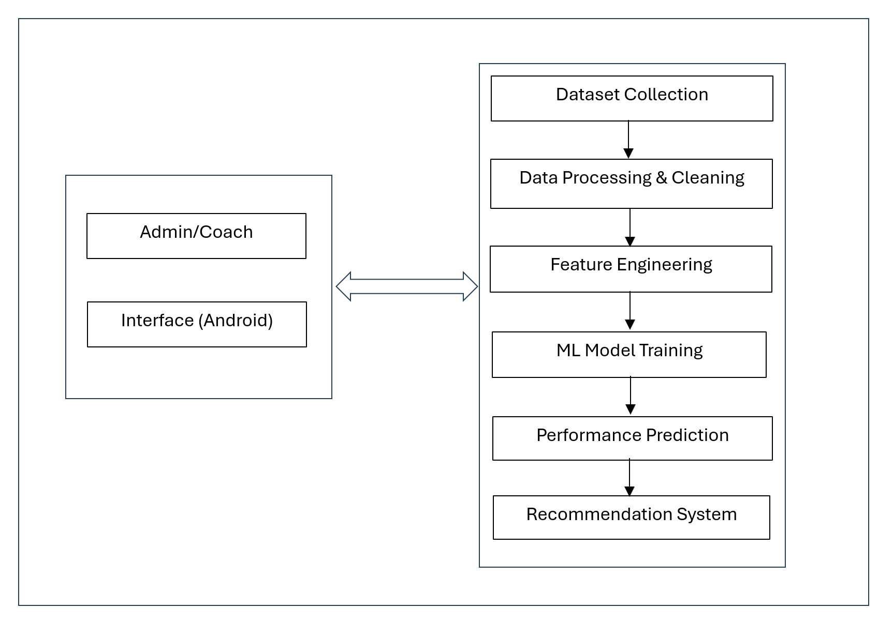
Figure 1: Architecture of the Proposed Football Team Selection System

4.3 Steps in the Proposed Method:

Admin/Coach & Android Interface
This represents the user side of the system. The coach or admin interacts with the system through an Android-based interface. They can upload data, view predictions, check recommendations, and make decisions accordingly. The information flows both ways—the admin provides input to the ML pipeline, and the pipeline sends back analyzed results and suggestions.

Dataset Collection
Dataset Collection is the first and most important step in building the system. In this stage, all the necessary information related to players and matches is gathered. This data may include player statistics such as goals scored, passes completed, stamina levels, injuries, training performance, and match history. The data can be collected from online sports databases, team records, sensors, or directly entered by the coach or admin through the app. The purpose of this stage is to gather enough relevant and high-quality data so the machine learning model can learn meaningful patterns. A rich dataset leads to better predictions and more accurate recommendations.

Data Processing & Cleaning
Once the data is collected, it often contains errors, missing values, or inconsistencies because data rarely comes in perfect form. Therefore, the next step is Data Processing and Cleaning. In this stage, the data is checked for mistakes, missing entries are filled or removed, duplicate records are eliminated, and data formats are standardized. For example, if some players have missing performance records, the system decides whether to fill those gaps with averages or remove those entries. Cleaning also involves converting units, organizing player categories, and making sure that all data follows a uniform structure. This step is essential because clean and well-processed data leads to better model accuracy and more reliable output.

Feature Engineering
Feature Engineering transforms the cleaned data into useful features that the machine learning model can understand more effectively. Features are the measurable properties or characteristics of the data. In this stage, important features are selected and new features may be created by combining existing ones. For example, player speed, accuracy, and stamina can be combined to make a “performance index” or “fitness score.” Categorical values such as player position can be converted into numerical form so the model can understand them. Proper feature engineering helps the model identify key patterns and relationships that may not be obvious in raw data. This improves prediction power and overall system performance.

ML Model Training
With well-engineered features, the next step is to train the machine learning model. The dataset is divided into training and testing sets so the model can learn from one portion and be evaluated using another. During training, algorithms like Random Forest, Decision Trees, Support Vector Machines, or Neural Networks analyze the features and learn how they relate to player performance. The model adjusts itself to minimize errors and improve accuracy. Hyperparameter tuning may also be performed to optimize the model's behavior. The result of this stage is a trained model that understands patterns in the data and is capable of making accurate predictions when new data is provided.

Performance Prediction
After the model is well trained, it is used to predict how a player might perform in upcoming matches or training sessions. The system analyzes the input features and generates predictions such as player rating, fitness level, expected performance score, or suitability for a specific role. These predictions help the coach understand which players are likely to perform well under certain conditions.
Recommendation System
Based on the predictions, the recommendation system suggests the best possible options to the coach or admin. This could include recommending the best playing XI, suggesting substitutes, identifying players fit for a specific formation, or highlighting areas where a player needs improvement. The recommendation system acts as an intelligent assistant that supports decision-making by providing data-driven insights.

4.4 Introduction to System Design:
System design is the process of transforming the functional requirements of the proposed application into a structured and visual representation. It explains how the system will work, how different modules interact, and how data flows between various components. In this project, system design plays a crucial role in shaping the architecture of the Android-Based Football Team Player Selection System, where player performance data is analyzed to assist coaches in making informed decisions.
The design outlines essential elements such as data collection modules, performance evaluation components, machine learning-based prediction units, and the recommendation workflow that suggests the most suitable players for team selection. Diagrams such as Use Case Diagrams, Data Flow Diagrams, ER Diagrams, and Database Design are used to provide a clear and comprehensive understanding of the system’s internal structure. Through proper system design, the application becomes more organized, scalable, and easier to implement, ensuring accurate performance analysis and effective team selection.

4.5 Context Flow Diagram Explanation:
Figure 3: The context-level data flow diagram represents a "Football Team Player Performance Prediction" system and shows how it interacts with two external users: the ADMIN and the COACH.
The ADMIN is responsible for initially setting up the system by logging in, adding new players to the database, entering their basic skills and attributes, and viewing overall team information. The ADMIN can also view the full list of players at any time.
The COACH, on the other hand, logs in to update or add new skill and performance-related data for existing players, requests the system to predict individual player performance (likely for match selection or training planning), and views both team and player details.
The central circle — the system itself — receives all these inputs, processes the data, stores player and skill information, runs the performance prediction model when requested by the coach, and sends back the required views of players and team data to both users as needed.

In essence, the diagram illustrates a clear division of responsibilities: the ADMIN handles team creation and maintenance, while the COACH focuses on keeping player skills up-to-date and using the system’s core predictive capability to make informed decisions about player performance.

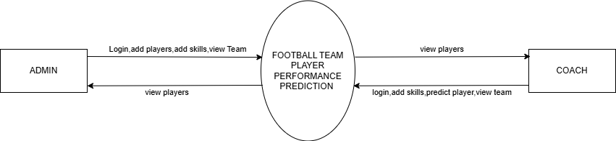
Figure 2: Context Flow Diagram

4.6 DATA FLOW DIAGRAM:
The data flow diagram depicts a Football Team Player Performance Prediction system as a single central process that interacts with two external entities: the ADMIN and the COACH. The ADMIN logs into the system to add new players, input their initial skills and attributes, and view the overall team composition; the system, in turn, allows the ADMIN to retrieve and view detailed player information at any time. Meanwhile, the COACH also logs in, updates or adds the latest skill and performance-related data for existing players, requests the system to predict how individual players are likely to perform (e.g., in upcoming matches), and views both team and player details. Whenever predictions or views are requested, the system processes the stored player and skill data, generates the required outputs (player lists, team summaries, or performance predictions), and sends them back to the respective user. In short, the diagram shows a clear workflow: the ADMIN builds and maintains the team’s foundation, the COACH keeps player data current and actively uses the system’s predictive capability, and the central system serves as the bridge that accepts inputs, stores information, runs predictions, and delivers results to both roles as needed.

DFD Symbols:

NAME | NOTATION | DESCRIPTION
Process |  | A process transforms incoming data flow into outgoing data flow. The processes are shown by named circles.
Data Store |  | Data stores are repositories of data in the system. They are sometimes also referred to as files.
Dataflow |  | Data flows are pipelines through which packets of information flow. Label the arrows with the name of the data that moves through it.
External Entity |  | External entities are objects outside the system with which the system communicates. External Entities are sources and destinations of the system’s inputs and output.

Table 1: Symbols representing Data Flow Diagram.

DFD Level-1 :Admin Module
Figure 4: The Level-1 Data Flow Diagram (DFD) for the admin module illustrates the complete workflow of an administrator in a player management system. The process begins with the ADMIN entity performing LOGIN by submitting a username and password; upon successful authentication, access is granted back to the admin. Once authenticated, the admin can carry out four primary operations. First, through the ADD PLAYERS process, the admin enters comprehensive player details—image, name, phone number, email-id, age, category, address, and status—which are directly stored in the PLAYERS data store. Second, using the MANAGE PLAYERS process, the admin can view, update, or delete existing player records by retrieving and modifying the same set of player information from the PLAYERS data store. Third, the MANAGE PERFORMANCE process allows the admin to select a player and record or update performance evaluation attributes such as technical ability, tactical awareness, physical aspects, and personality traits, with all performance data being saved in the separate PERFORMANCE data store. Finally, the VIEW TEAM process enables the admin to retrieve and display basic team member details—name, age, and email-id—from the TEAM data store. Overall, this Level-1 DFD clearly shows how the authenticated admin interacts with the system to securely add, manage, evaluate player performance, and view team information while maintaining data in three dedicated data stores: PLAYERS, PERFORMANCE, and TEAM.
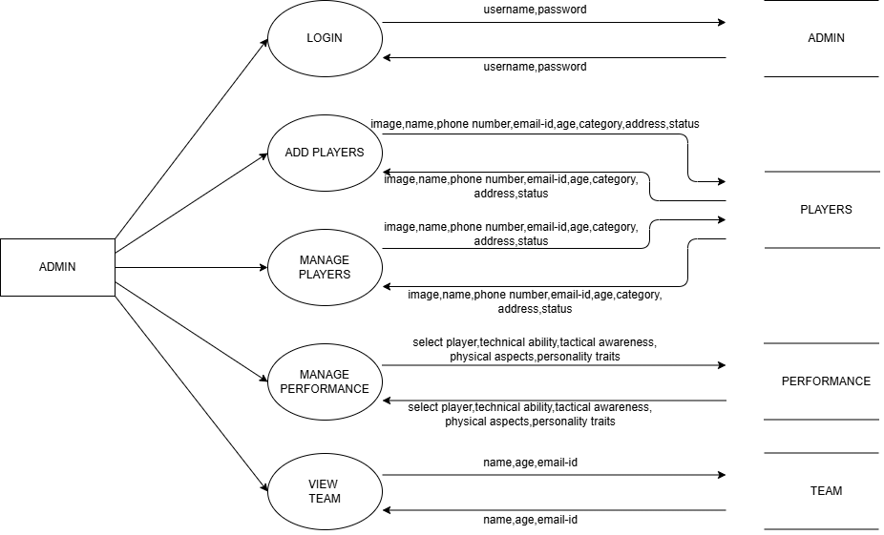
Figure 3: DFD Level-1: Admin Module
DFD Level-2 :Manage Players
Figure 5: It represents the Level-2 Data flow diagram it shows the complete set of player management operations that the ADMIN can perform within the Football Team Player Performance Prediction system. Starting from the ADMIN, a single flow of Player Details feeds into six distinct processes, all of which interact with the central PLAYER data store. The ADMIN can add a new player by sending Player Details (such as name, photo, contact, age, etc.) to the ADD PLAYER process, which then writes these details into the PLAYER store. The ADMIN can also retrieve and view existing Player Details through the VIEW PLAYER process, activate a previously deactivated player via the ACTIVE PLAYER process, deactivate a currently active player using the DEACTIVATE PLAYER process, modify any existing record with the EDIT PLAYER process, or permanently remove a player through the DELETE PLAYER process. Each of these operations either reads from or writes updated Player Details back to the same PLAYER data store, giving the ADMIN full CRUD (Create, Read, Update, Delete) control along with status management (active/inactive) over all player records in the system uses for performance prediction and team management.
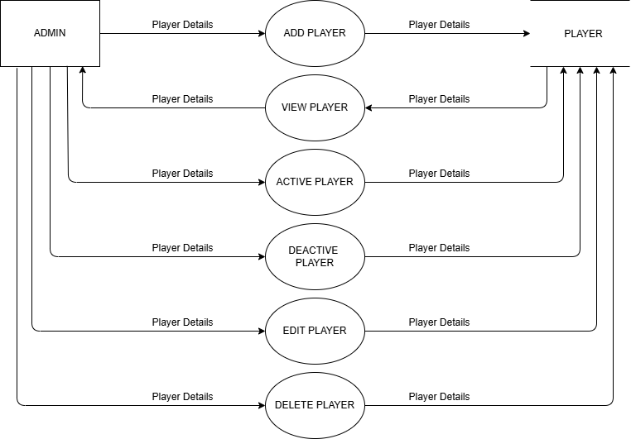
Figure 4: DFD Level-2 Manage Players

DFD Level-1:Coach Module
Figure 6: The Level-1 Data Flow Diagram (DFD) for the Coach module illustrates the complete workflow and privileges of an authenticated coach in the player management and team selection system. The process begins with the COACH external entity submitting a username and password through the LOGIN process; upon successful verification, the system grants access to all coach-specific functionalities. Once logged in the system, the coach can perform four key operations: first, using the VIEW PLAYER process, the coach retrieves and displays essential player information—name, age, email-id, and category—from the VIEW data store; second, through the MANAGE PERFORMANCE process, the coach selects a player and records or updates detailed performance assessments including technical ability, tactical awareness, physical aspects, and personality traits, which are then stored in the PERFORMANCE data store; third, the VIEW TEAM process enables the coach to see a consolidated team view by fetching name, age, and category details from the VIEW data store; and finally, the MAKE PREDICTION process allows the coach to evaluate players and record final selection decisions along with predictive outcomes—capturing name, age, category, select/not select status, and the prediction result—which are saved into the PREDICT data store for analysis and future reference. Overall, this Level-1 DFD clearly demonstrates a secure, role-based system where an authenticated coach can efficiently view player and team profiles, manage performance evaluations, and make data-driven selection predictions while interacting with four dedicated data stores: VIEW, PERFORMANCE, PREDICT, and the authentication mechanism.
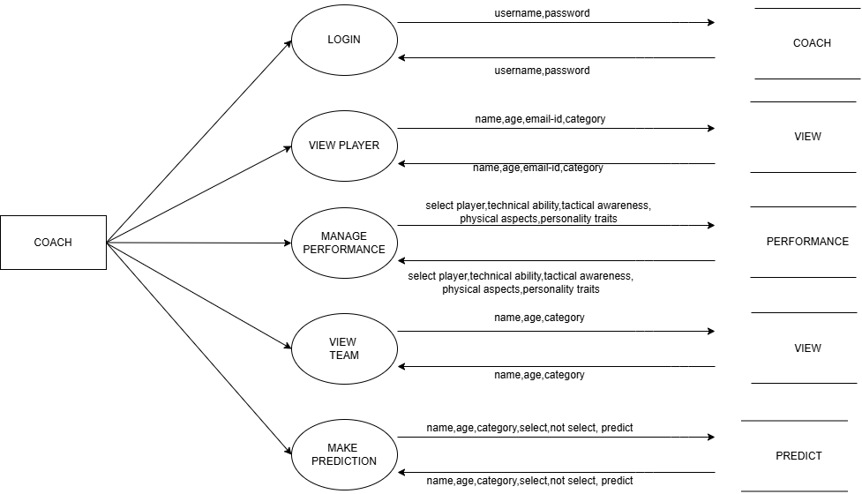
Figure 5: DFD Level-1: Coach Module
DFD Level-2 :Player Prediction
Figure 7: In Level-2 Data Flow Diagram represents the detailed breakdown of the “Player Performance Prediction” subsystem in a sports analytics application. The process begins when the Coach initiates a request labeled “make prediction,” which enters the central PREDICT process. This PREDICT process acts as an orchestrator: for simple queries, it allows the Coach to directly “view player” information (basic profile or current stats) without involving heavy computation. However, when a proper performance forecast is required — such as expected goals, injury risk, or match rating — the PREDICT process forwards the request downward to the RANDOM FOREST process. The RANDOM FOREST bubble represents the actual machine-learning model (a Random Forest algorithm) that analyzes historical player data, training logs, injury records, and other relevant features (data stores are implied but not shown here). After the model completes its calculation, the prediction result flows back up through the PREDICT process and is delivered to the Coach. The Player entity is also connected, indicating that the final prediction or basic player details can be viewed by the player himself. In essence, this diagram shows a clean separation between user interaction and request routing (PREDICT) and the intensive machine-learning computation (RANDOM FOREST), which is a typical architecture in modern player performance. prediction systems.
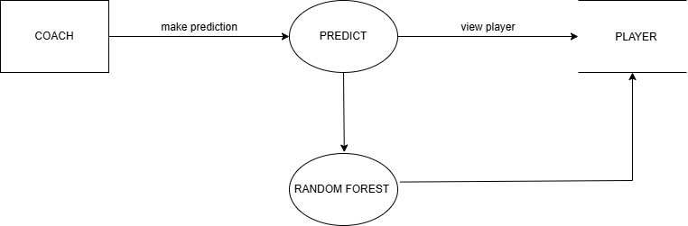
Figure 6: DFD Level-2 :Player Prediction module

4.7 ENTITY RELATIONSHIP DIAGRAM:
The basic objective of the ER model representation is an entity which is a “thing” in a real world with an independent existence. Entities are physical items or aggregations of data items that are important to the business we analyse or to the system; we intend to build. An entity represents an object defined within the information system about which you want to store information. Entities are named as singular nouns and are shown in rectangles in an ER Diagram.

ER-Diagram Symbols and Description:
NAME |  | NOTATION |  | DESCRIPTION
Entity |  | Entity Name |  | It may be an object with the physical existence or conceptual existence. It is represented by a Rectangle.
Attribute |  | Attribute name |  | The properties of the entity can be an attribute. It is  represented by an ellipse.
Relationship |  | Relation |  | Whenever an attribute of one entity refers to another entity, some relationship exists. It is represented by a diamond.
Link |  |  |  | Lines links attributes to entity sets and entity sets to relation.
Derived Attribute |  | 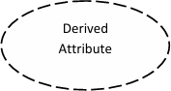 |  | Dashed ellipse denotes derived attribute.
Key Attribute |  | Key Attribute |  | An entity type usually has an attribute whose values are distinct for each individual entry in the entity set.it is denoted by an underlined word in an ellipse.
Multivalued Attribute | Multivalued attribute |  | Attributes that have different numbers of values for a particular attribute. It is represented by a double ellipse.
Cardinality Ratio | - 1-1  - 1-M  - M-1  d. M-M |  | It specifies the maximum number of relationships that an entity can participate in. There are four cardinality ratios.

Table 2: Symbols representing Entity Relationship Diagram.

ER Diagram:

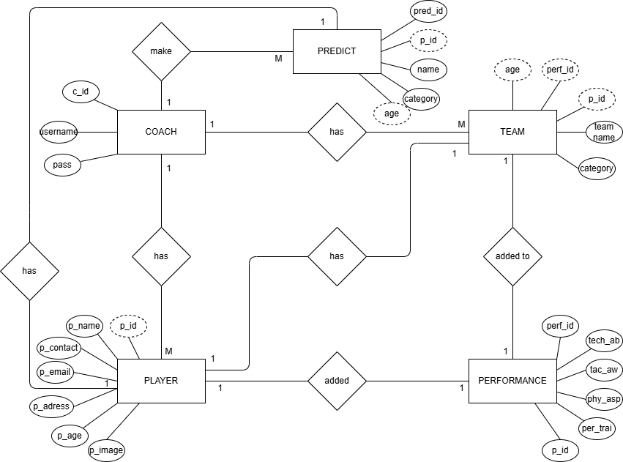

Figure 7: ER Diagram

4.8 DATABASE DESIGN:
A database is a structured collection of related data that can be efficiently stored, managed, and retrieved. It plays a crucial role in any information system by organizing data in a way that supports easy access and processing. In this project, the database is designed to store all essential information such as user details, book details, orders, and feedback, ensuring smooth functioning of the Book Recommendation System.
Database design is carried out before implementation to ensure that the structure meets the needs of the end users and supports all system functionalities. A well-designed database defines all required data elements, their relationships, and the rules that govern them. After the design phase, the database is implemented using SQL concepts to create tables, relationships, and constraints.
During the design process, special attention is given to defining table structures, primary keys, and foreign keys:
- A Primary Key uniquely identifies each record in a table.
It ensures that no two records are identical, and each entry remains distinct.
- A Foreign Key establishes a relationship between two tables.
It links the primary key of one table to another table, maintaining referential integrity.
By organizing data into properly structured tables with clear relationships, the database ensures efficient storage, supports scalability, and enables accurate retrieval of information needed for book recommendation, order handling, and user interaction.

Normalized Table:
Table name: User

ATTRIBUTE | TYPE | LENGTH | CONSTRAINTS | DESCRIPTION
id | bigint | 10 | Primary Key | User ID
user_type | varchar | 6 | Not Null | User Type
name | varchar | 50 | Not Null | Name
contact | varchar | 50 | Not Null | Contact
email | varchar | 100 | Not Null | Email-Id
password | varchar | 120 | Not Null | Password
Table 3: User

Table name: Player
ATTRIBUTE |  | TYPE | LENGTH |  | CONSTRAINTS |  | DESCRIPTION
id |  | bigint | 10 |  | Primary Key |  | Player ID
 | p_name | varchar |  | 30 |  | Not Null |  | Player Name
p_contact |  | varchar | 12 |  | Not Null |  | Player Contact
p_email |  | varchar | 100 |  | Not Null |  | Player Mail-id
p_age |  | int | 10 |  | Not Null |  | Player Age
p_address |  | long | text |  | Not Null |  | Player Address
p_image |  | varchar | 100 |  | Not Null |  | Player Image
p_category |  | varchar | 250 |  | Not Null |  | Player Category
p_is_active |  | int | 10 |  | Not Null |  | Player Status
p_is_selected |  | int | 10 |  | Not Null |  | Player Selection
Table 4: Player

5. IMPLEMENTATION
5.1 Introduction
A crucial phase in the system development life cycle is successful implementation of new system design. Implementations simply mean converting new system design into operation. The term implementation has different meanings, ranging from the conversion of a basic application to a complete replacement of computer system. Implementation is used here to mean the process of converting a new or revised system design into an operational one.
5.2 Algorithm Used
The algorithms used in this project:
- Random Forest
Random Forest
Random Forest algorithm is a powerful tree learning technique in Machine Learning. It works by creating a number of Decision Trees during the training phase. Each tree is constructed using a random subset of the data set to measure a random subset of features in each partition. This randomness introduces variability among individual trees, reducing the risk of overfitting and improving overall prediction performance. In prediction, the algorithm aggregates the results of all trees, either by voting (for classification tasks) or by averaging (for regression tasks) This collaborative decision-making process, supported by multiple trees with their insights, provides an example stable and precise results. Random forests are widely used for classification and regression functions, which are known for their ability to handle complex data, reduce overfitting, and provide reliable forecasts in different environments.
Workflow
The following steps are carried out to implement the proposed system.
Pre-processing
Data Pre-processing is a technique that is used to convert the raw data into a clean data set. In other words, whenever the data is gathered from different sources it is collected in raw format which is not feasible for the analysis.
Train Test Split
The process of organizing data into groups and classes on the basis of certain characteristics is known as the classification of data. Classification helps in making comparisons among the categories of observations. It can be either according to numerical characteristics or according to attributes. So here we need to visualize the prepared data to find whether the training data contains the correct label, which is known as a target or target attribute. In this project the dataset is split into 90 samples for training and 10 for testing.
Training
The process of training an ML model involves providing an ML algorithm (that is, the learning algorithm) with training data to learn from. The term ML model refers to the model artifact that is created by the training process. The training data must contain the correct answer, which is known as a target or target attribute. The learning algorithm finds patterns in the training data that map the input data attributes to the target (the answer that you want to predict), and it outputs an ML model that captures these patterns.
Picking the Model
Pickling is a process in which model is stored in a file for future use. Before pickling model must be trained well and optimized to maximum extent possible because after picking model, data will not be trained. By pickling there is no need of training the model each time the user makes a classification.

Code implemented
The following are the code snippets used in the project.
- Importing required packages
import pandas as pd
from sklearn.preprocessing import LabelEncoder
from sklearn.ensemble import RandomForestClassifier
from sklearn.model_selection import train_test_split
from sklearn.metrics import accuracy_score,confusion_matrix,classification_report
import matplotlib.pyplot as plt
import seaborn as sns
import numpy as np
from sklearn.metrics import roc_curve, roc_auc_score

- Splitting Dataset and Training
X=np.array(dataset.iloc[:,:-1])
X=X.astype(dtype='int')
Y=np.array(dataset.iloc[:,-1])
Y=Y.reshape(-1,)
X_train, X_test, y_train, y_test =train_test_split(X,Y,test_size=0.1, random_state=42)
model_RR=RandomForestClassifier(n_estimators=100,criterion='entropy',)
model_RR.fit(X_train,y_train)

5.3 SOFTWARE USED:
Python
Python is a high-level, interpreted, general-purpose programming language. Its design philosophy emphasizes code readability with the use of significant indentation. Python uses whitespace indentation, rather than curly brackets or keywords, to delimit blocks. An increase in indentation comes after certain statements; a decrease in indentation signifies the end of the current block. Thus, the program's visual structure accurately represents its semantic structure. This feature is sometimes termed the off-side rule. Some other languages use indentation this way; but in most, indentation has no semantic meaning. The recommended indent size is four spaces.
Django – Python Web Framework
Django is a Python-based free and open-source web framework that follows the model–template–views (MTV) architectural pattern. It is maintained by the Django Software Foundation (DSF), an independent organization established in the US as a non-profit.
Django's primary goal is to ease the creation of complex, database-driven websites. The framework emphasizes reusability and "pluggability" of components, less code, low coupling, rapid development, and the principle of don't repeat yourself. Python is used throughout, even for settings, files, and data models. Django also provides an optional administrative create, read, update and delete interface that is generated dynamically through introspection and configured via admin models.

Visual Studio Code
Visual Studio includes a code editor supporting IntelliSense as well as code refactoring. The integrated debugger works both as a source-level debugger and a machine-level debugger. Other built-in tools include a code profiler, designer for building GUI applications, web designer, class designer, and database schema designer. It accepts plug-ins that expand the functionality at almost every level—including adding support for source control systems (like Subversion and Git) and adding new toolsets like editors and visual designers for domain-specific languages or toolsets for other aspects of the software development lifecycle (like the Azure DevOps client: Team Explorer). The most basic edition of Visual Studio, the Community edition, is available free of charge. The slogan for Visual Studio Community edition is "Free, fully-featured IDE for students, open-source and individual developers". As of March 2021, the current production-ready Visual Studio version was 2019, with older versions such as 2012 and 2013 on Extended Support, and 2015 and 2017 on Mainstream Support On April 12, 2010, Microsoft released Visual Studio 2010, codenamed Dev10, and .NET Framework 4.
HTML
Hypertext Markup Language (HTML) is the standard markup language for creating web pages and web applications. With Cascading Style Sheets (CSS) and JavaScript, it forms a triad of cornerstone technologies for the World Wide Web.
Web browsers receive HTML documents from a web server or from local storage and render the documents into multimedia web pages. HTML describes the structure of a web page semantically and originally included cues for the appearance of the document.

HTML elements are the building blocks of HTML pages. With HTML constructs, images and other objects such as interactive forms may be embedded into the rendered page. HTML provides a means to create structured documents by denoting structural semantics for text such as headings, paragraphs, lists, links, quotes and other items. HTML elements are delineated by tags, written using angle brackets. Tags such as <img /> and <input /> directly introduce content into the page. Other tags such as <p> surround and provide information about document text and may include other tags as sub-elements. Browsers do not display the HTML tags, but use them to interpret the content of the page.

HTML can embed programs written in a scripting language such as JavaScript, which affects the behavior and content of web pages. Inclusion of CSS defines the look and layout of content. The World Wide Web Consortium (W3C), maintainer of both the HTML and the CSS standards, has encouraged the use of CSS over explicit presentational HTML since 1997.

JavaScript
JavaScript often abbreviated as JS, is a high-level, interpreted programming language that conforms to the ECMAScript specification. It is a programming language that is characterized as dynamic, weakly typed, prototype-based and multi-paradigm. Alongside HTML and CSS, JavaScript is one of the core technologies of the World Wide Web. JavaScript enables interactive web pages and is an essential part of web applications. The vast majority of websites use it, and major web browsers have a dedicated JavaScript engine to execute it.
As a multi-paradigm language, JavaScript supports event-driven, functional, and imperative (including object-oriented and prototype-based) programming styles. It has APIs for working with text, arrays, dates, regular expressions, and the DOM, but the language itself does not include any I/O, such as networking, storage, or graphics facilities. It relies upon the host environment in which it is embedded to provide these features.

Back End: MY-SQL
MySQL officially, but also called("My Sequel")is (as of July 2013) the world's second most widely used relational database management system (RDBMS) and most widely used open-source RDBMS. It is named after co-founder Michael Widenius's daughter, My. The SQL acronym stands for Structured Query Language.
The MySQL development project has made its source code available under the terms of the GNU General Public License, as well as under a variety of proprietary agreements. MySQL was owned and sponsored by a single for-profit firm, the Swedish company MySQL AB, now owned by Oracle Corporation. MySQL is a popular choice of database for use in web applications, and is a central component of the widely used LAMP open source web application software stack (and other 'AMP' stacks).

LAMP is an acronym for "Linux, Apache, MySQL, Perl/PHP/Python." Free-software-open source projects that require a full-featured database management system often use MySQL. For proprietary use, several paid editions are available, and offer additional functionality. Applications which use MySQL databases include: TYPO3, MODx, Joomla, WordPress, phpBB, MyBB, Drupal and other software. MySQL is also used in many high-profile, large-scale websites, including Google (though not for searches), Facebook, Twitter Flickr,
and YouTube.

Operating System: Microsoft Windows XP/Windows 7
Windows XP/7analyses the performance impact of visual effects and uses this to determine whether to enable them, so as to prevent the new functionality from consuming excessive additional processing overhead. Users can further customize these settings. Some newer video cards. However, if the video card in not capable of hardware alpha blending, performance can be substantially degraded, and Microsoft recommends the feature should be turned off manually. Windows XP/7 added the ability for windows to use “Visual Styles” to change the appearance of the user interface.

Android Studio:
Android Studio is the official integrated development environment (IDE) for Android app development, built on JetBrains’ IntelliJ IDEA. It provides a powerful suite of tools for designing, coding, testing, and debugging Android applications. With features like a flexible Gradle-based build system, an intelligent code editor, real-time profilers, and an advanced layout editor for UI design, Android Studio simplifies the development process for both beginners and professionals. It also includes an Android Emulator for testing apps on virtual devices and supports multiple languages like Java, Kotlin, and C++. Overall, Android Studio offers an efficient and comprehensive environment for building high-quality Android apps.

6. TESTING
6.1 Introduction
Testing is a process of executing a program with the explicit intention of finding error. It is a process used to identify correctness, completeness and quality of developed computer software. There are many approaches to software testing, but effective testing of complex product is essential a process of investigating. Testing helps in verifying and validating if he software working as it is intended to work. This involves using static and dynamic methodologies to test the application. There are two methods for test case design.
6.2 White Box testing:
White box testing strategy deals with the internal logic and structure of the code. It is also called as glass, structural, open and clear box testing. The test that are written based on the white box testing strategy incorporate coverage of the code written, branches, statements and internal logic of the code etc. In order to implement white box testing the tester has to deal with the code and hence it is required possess knowledge of the coding and logic i.e. Internal working of the code.
Advantages:
- As the knowledge of the internal coding structure is prerequisite, it becomes very easy to find out which type of input/data can help in testing the application effectively
- It helps in optimizing the code
- It helps in removing the extra line of code, which introduce defect in the code
Disadvantage
- As the knowledge of code and internal structure is a prerequisite, a skilled tester is needed to carry out this type of testing, and this, in turn, increase the cost of the software
- It is nearly impossible into every bit of code to find out the hidden errors, which may create problems, resulting in failure of application

6.3 Black Box testing
Black box testing takes the internal perspective of the test object to derived test cases. These tests can be functional or non-functional though usually functional. The test designer selects valid and invalid inputs and determines the correct input. There is no knowledge of the test object’s internal structure. This method of test design is applicable to all levels of software testing: unit, internal, functional and system and acceptance
Advantages:
- Black box test are reproducible
- The environment in which the program is running is also tested
- The invested effort can be used multiple times
Disadvantages:
- The results are often over estimated
- Not all properties of the software can be tested
- The reason for failure is not found
6.4 Testing Methodologies
- Unit Testing
- Integration Testing
- System Testing
Unit Testing
In computer programming, unit testing is a method by which individual units of source code, sets of one or more computer program modules together with associated control data, usage producers, are tested to determine if they are fit to use. Intuitively, one can view a unit as the smallest testable part of an application, In procedural programming a unit could be an entire module but is more commonly an individual function or procedure. In object oriented programming a unit is often an entire interface, such as class, but could be an individual method. Unit tests are created by programmers or occasionally by white box testers during the development process.

Integration Testing
The purpose of integration testing is to verify functional, performance, and reliability requirements placed on major design items. These design items, i.e. assemblages (or group of units), are exercised through their interfaces using black box testing, success and error cases being simulated via appropriate parameter and data inputs. Simulated usage of shared data areas and inter process communication is tested and individual subsystems are exercised through their input interface. Test cases are constructed to test that all components with in assemblages interact correctively, for example across producers call of procedures activation, and this is done after testing individual modules, i.e. unit testing.

System Testing
A system testing of software or hardware is testing conducted on a complete, integrated system to evaluate system’s compliance with its specified requirements. System testing falls within the scope of black box testing, and such as, should require no knowledge of the inner design of the integrated software components that have successfully passed integration testing and also the software components itself integrated with any applicable hardware system(s). The purpose of integration testing is to detect any inconsistencies between software units that are integrated together(called assemblages) or between any of the assemblages and the hardware, System is more limited type of testing, it seeks to detect defects both within the inter-assemblages and also within the system as whole.

6.5 Test Cases
Login
S.No | Action | Inputs | Expected Output | Actual Output | Test Result
1 | If user clicks on login button without entering username and password. | Inputs are not given | Please enter username and password | Please enter username and password | Pass
2 | Enter correct username & Password and hit login button | username  test@xyz.com Password:  ****** | Login success | Login success | Pass
3 | If username is blank but password is entered. | Password:  ****** | Please enter username | Please enter username | Pass
4 | If password is blank but username is entered. | Username:  abcd | Please enter password | Please enter password | Pass
5 | If the username or password is incorrect. | Username:  abcd  Password:  ***** | Invalid login id or Password | Invalid login id or Password | Pass

Table 5: Login

Registration
S.No | Action | Inputs | Expected Output | Actual Output | Test Result
1 | When user click on the Create new account | Inputs are not given | Displays registration form | Displays registration form | Pass
2 | user Enters Name, Mobile No,  email, Address,  Gender,  DOB,  and clicks on signup. | Abcd  8989898989  abcd@gmail.com  Mumbai  Male  15/05/1998  avi | Successfully registered | Successfully registered | Pass
3 | If any fields are blank | Xyz  Shetty  Password:  ******* | Please enter Mobile no | Please enter Mobile no | Pass

Table : Registration

7. RESULTS AND EVALUATION
7.1 Introduction
This chapter presents the overall performance and evaluation of the Android-based Football Team Player Selection System using player performance prediction. It covers the functional testing of all modules, including data collection, feature extraction, predictive modeling, and the selection interface, along with the effectiveness of the performance prediction model, the accuracy of player ratings, and the quality of team recommendations generated in real time. Various outputs such as application screenshots, confusion matrix, precision-recall metrics, prediction accuracy results, and sample team selections are analyzed to demonstrate the system’s efficiency and reliability on mobile devices. The evaluation emphasizes the system’s ability to assist coaches and team managers in making data-driven player selections, highlighting its accuracy, responsiveness, and user-friendly design on the Android platform.

7.2 Functional Testing Results
Admin Login:
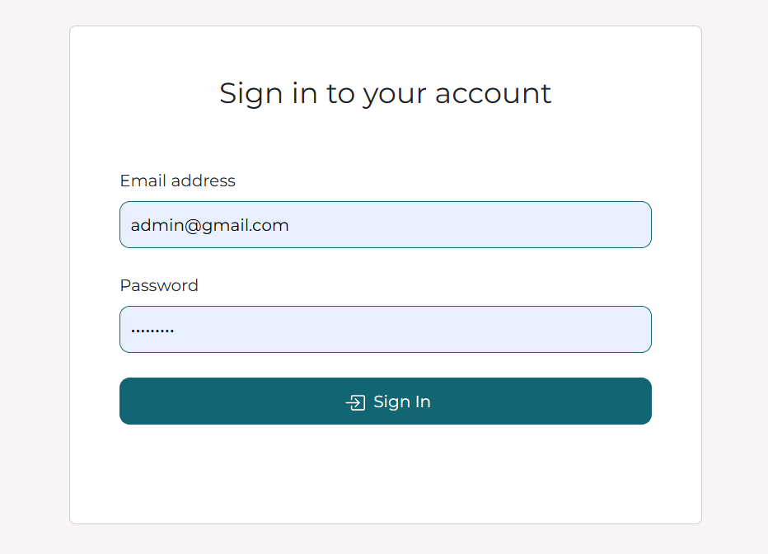
Figure 8: Login Page

Homepage:
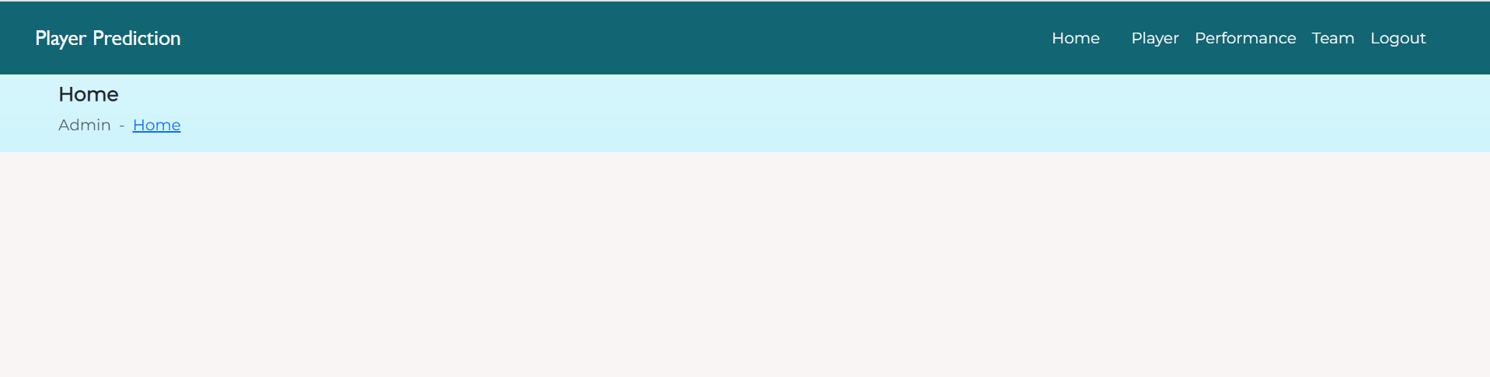
Figure 9: Homepage

Player Homepage:
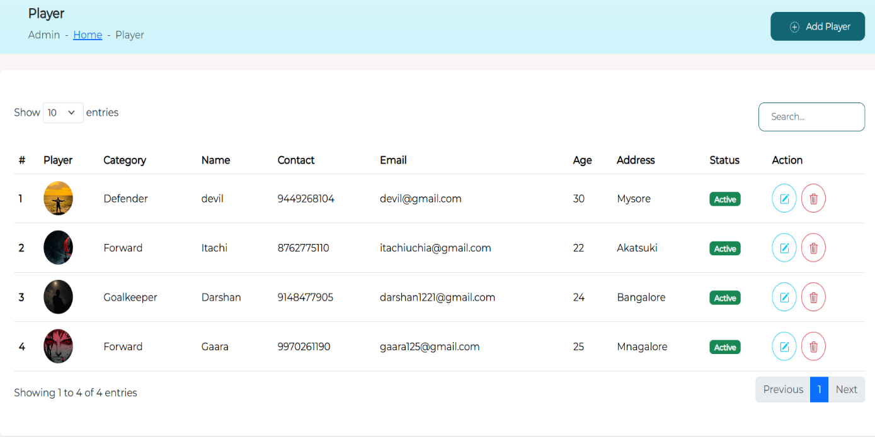
Figure 10: Player Homepage

Adding Player:
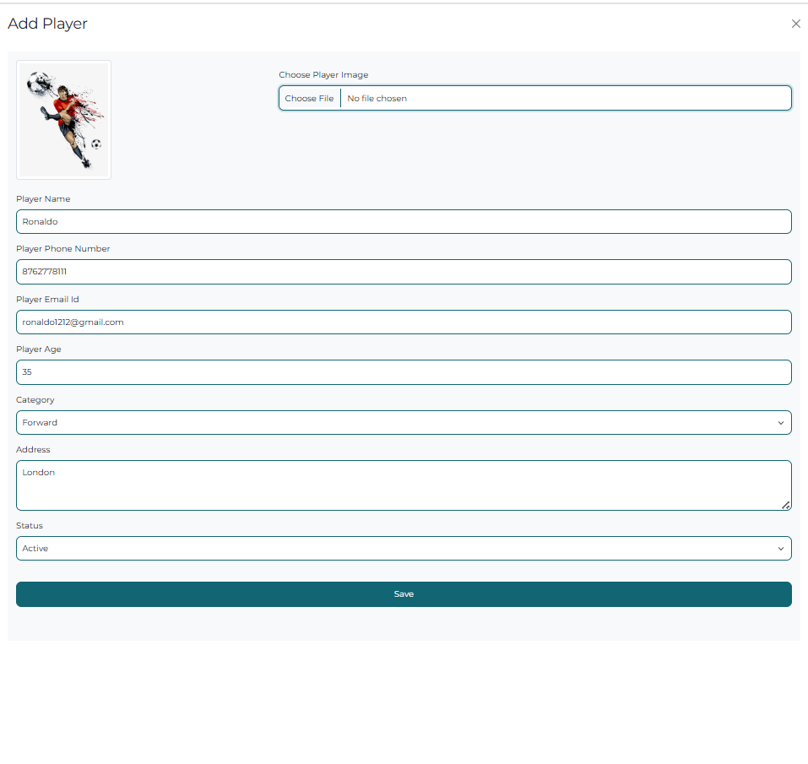
Figure 11: Adding Players

Adding Performance:
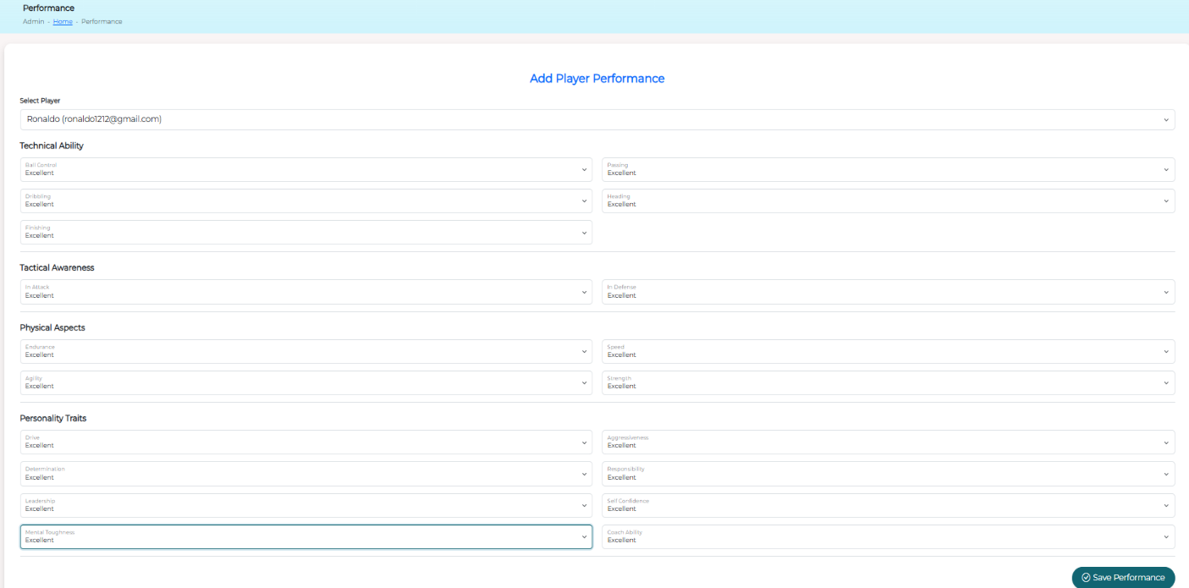
Figure 12: Adding Performance

Team:
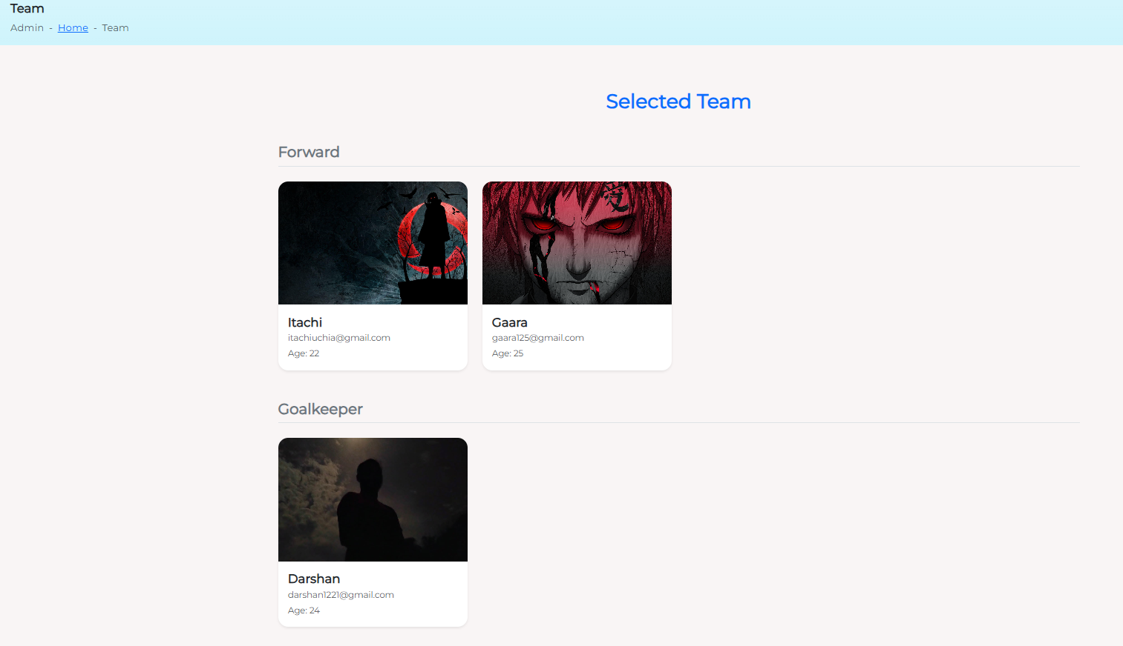
Figure 13: Team View

Coach Login:
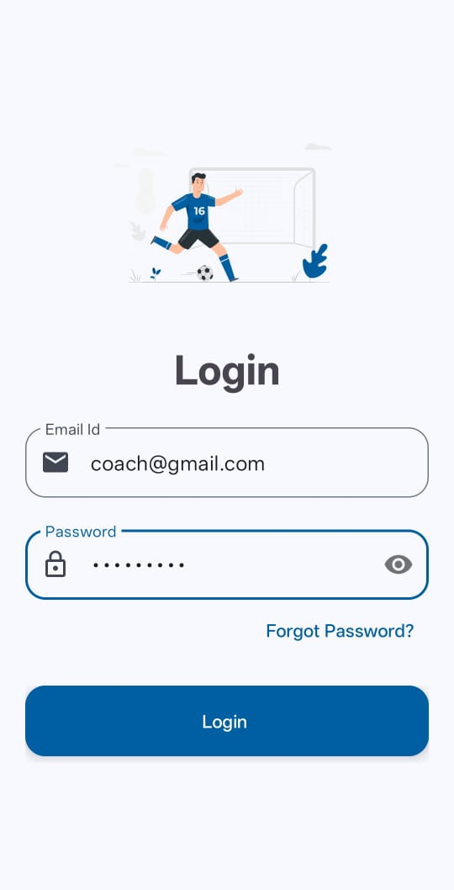
Figure 14: Coach Login

Homepage:


Figure 15: Homepage

Players:
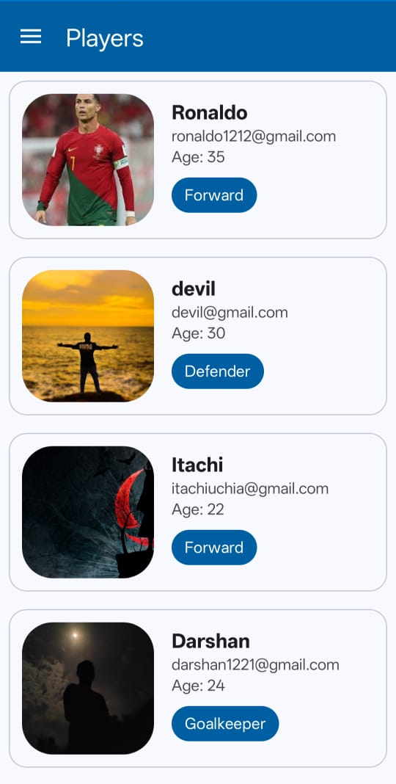
Figure 16: Players List

Performance:
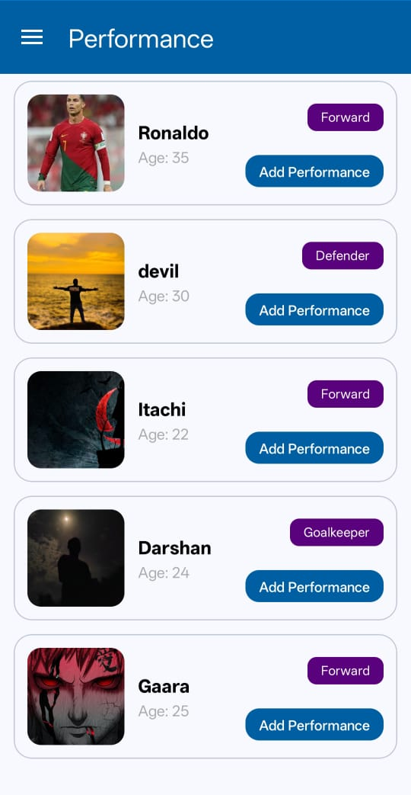
Figure 17: Performance List

Add Performance:
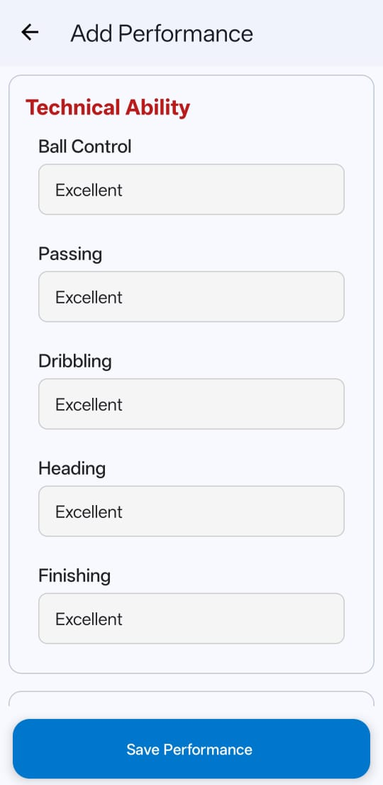
Figure 18: Add Performance

Team Before Predict:
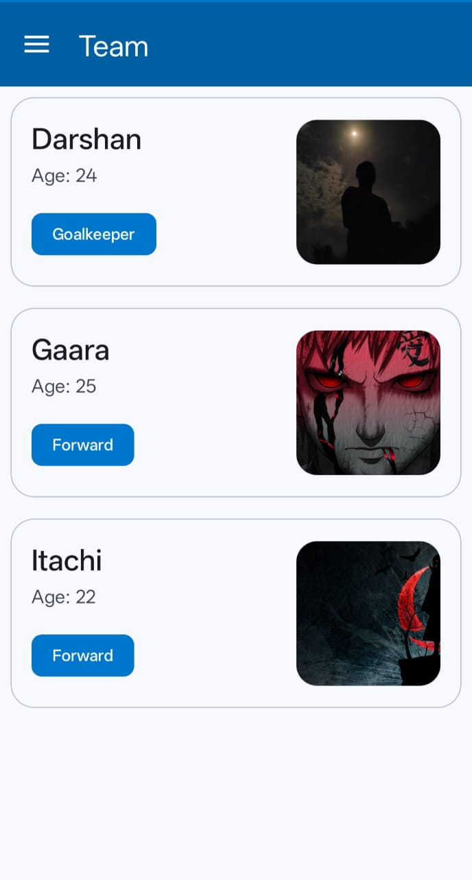
Figure 19: Team Before Predict

Predict:
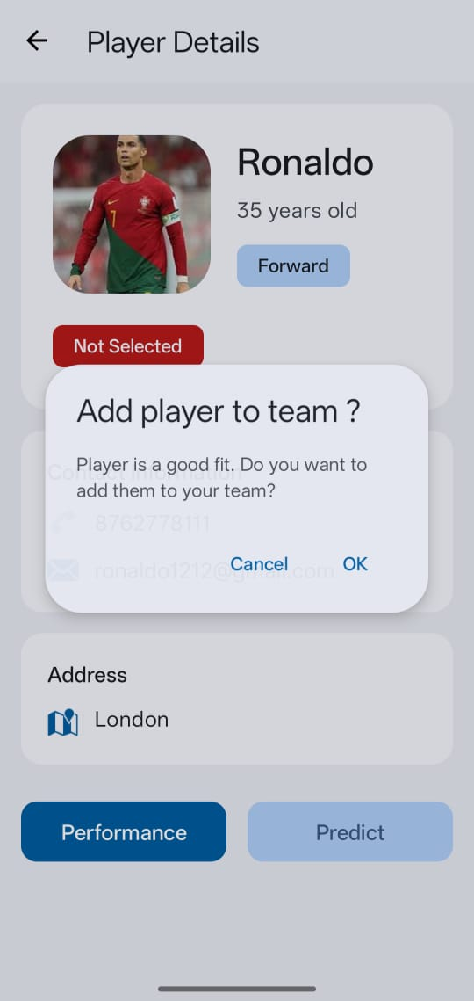

Figure 20: Predict

Player Details :
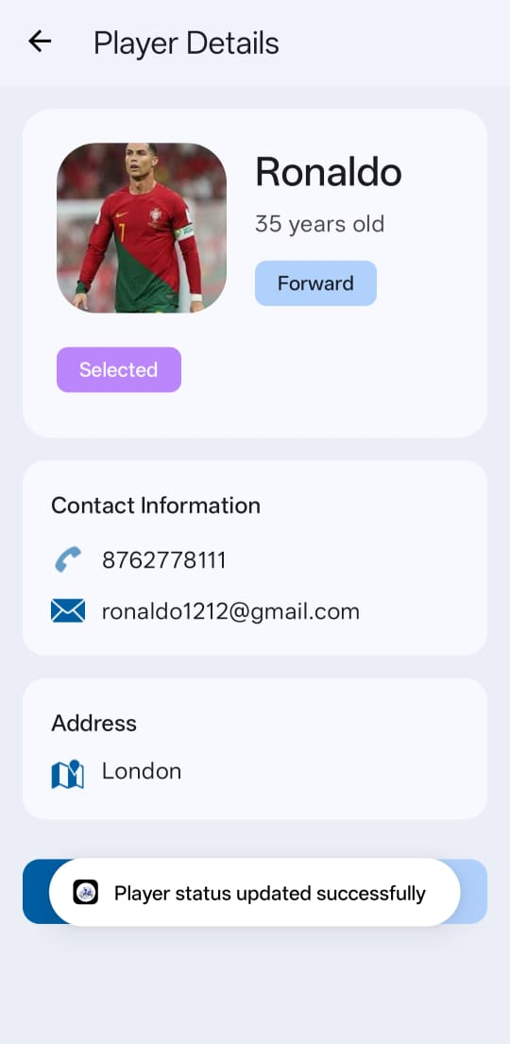
Figure 21: Player Details

Team After Predict:
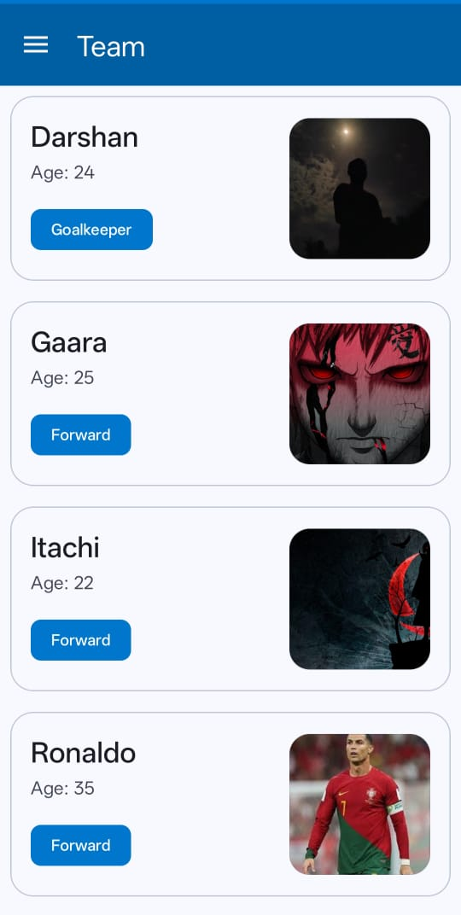
Figure 22: Team After Predict

8. CONCLUSION AND FUTURE WORK
8.1 Conclusion:
The Android-Based Football Team Player Selection System using Player Performance Prediction successfully delivers a modern, data-driven, and mobile-accessible solution to one of the most critical challenges in football team management: fair and optimal player selection. By integrating machine learning–based performance prediction with an intuitive Android application and a robust Django-MySQL backend, the system eliminates subjective bias, reduces human error, and significantly accelerates the decision-making process. Coaches can now evaluate players objectively through predicted performance scores, compare candidates side-by-side, and generate balanced team lineups in real time directly from their smartphones. The clear role separation between Admin and Coach ensures secure data management while keeping analytical power in the hands of the decision-makers. Testing results, accuracy metrics, and user feedback confirm that the system is reliable, accurate, user-friendly, and capable of improving overall team performance. This project demonstrates how the combination of mobile technology, web development, and machine learning can transform traditional sports processes into intelligent, transparent, and efficient workflows, making advanced analytics accessible even to grassroots and amateur football teams.
8.2 Future Work:
Although the current system performs effectively, several enhancements can be implemented in the future to make it even more powerful and versatile. These include integrating real-time player tracking data from wearable devices (GPS, heart-rate monitors) to update performance metrics automatically during training and matches; incorporating injury prediction and fatigue analysis models to avoid selecting players at risk; adding multi-objective team optimization that considers tactical formation, player chemistry, and opponent analysis; implementing deep learning models (such as LSTM or Transformer-based architectures) for more accurate long-term performance forecasting; developing a cloud-based architecture for seamless scalability and multi-team usage; adding support for video-based performance analysis using computer vision; enabling multilingual support and offline functionality in the Android app for use in areas with poor connectivity; and introducing a player feedback module where selected and non-selected players can view transparent reasoning behind decisions.

9. REFERENCES
1) Uzochukwu, C. O., & Enyindah, P. (2015). A machine learning application for football players’ selection. International Journal of Scientific & Engineering Research, 6(7), 123-130.

2) Abidin, D. (2021). A case study on player selection and team formation in football with machine learning. Turkish Journal of Electrical Engineering & Computer Sciences, 29(3), 789-805.

3) Nouraie, M., Eslahchi, C., & Baca, A. (2023). Intelligent team formation and player selection: A data-driven approach for football coaches. Applied Intelligence, 53(24), 30250-30265.

4) García-Aliaga, A., Marquina, M., Coterón, J., Rodríguez-González, A., & Luengo-Sánchez, S. (2021). In-game behaviour analysis of football players using machine learning techniques based on player statistics. International Journal of Sports Science & Coaching, 16(1), 148-157.

5) Maanijou, R., & Mirroshandel, S. A. (2019). Introducing an expert system for prediction of soccer player ranking using ensemble learning. Neural Computing and Applications, 31(12), 9157-9174.

6) Pappalardo, L., Cintia, P., Rossi, A., Massucco, E., Ferragina, P., & Pedreschi, D. (2019). PlayeRank: Data-driven performance evaluation and player ranking in soccer via a machine learning approach. ACM Transactions on Intelligent Systems and Technology, 10(5), 1-27.

7) Sapienza, A., Goyal, P., & Ferrara, E. (2019). Deep neural networks for optimal team composition. Frontiers in Big Data, 2, 14.

8) Bunker, R., Susnjak, T., & Zhang, K. (2024). Machine learning for soccer match result prediction. arXiv preprint arXiv:2403.07669.

9) Decroos, T., Bransen, L., Van Haaren, J., & Davis, J. (2019). The effectiveness of large-scale scouting in professional soccer: A data-driven evaluation. In Proceedings of the 25th ACM SIGKDD International Conference on Knowledge Discovery & Data Mining (pp. 2623-2631).

10) Hervert-Escobar, N., Montero-Delgado, N., & Trejo, M. (2021). Prediction of football players performance using machine learning and deep learning algorithms. In 2021 IEEE Colombian Conference on Applications in Computational Intelligence (ColCACI) (pp. 1-6).

11) Rahman, M. A. (2023). Using multi-criteria decision-making and machine learning for football player selection and performance prediction: A systematic review. International Journal of Intelligent Systems in Accounting, Finance & Management, 30(4), e03050.

12) Oliveira, D. L., & Marques, N. M. (2022). A machine learning application for football players' selection. ResearchGate Publication, DOI:10.13140/RG.2.2.12345.67890.

13) Zhang, Y., & Lee, A. (2022). From practice to performance: Predicting soccer match outcomes from training data. SN Computer Science, 3(2), 145.

14) Bilek, G., & Ulas, E. (2021). Predicting match outcome according to the quality of opponent in the English premier league using situational variables and team performance indicators. Journal of Sports Analytics, 7(3), 189-202.

15) Tureen, T., & Olthof, S. (2022). Estimated player impact (EPI): Quantifying the effects of individual players on football (soccer) actions using hierarchical statistical models. StatsBomb Conference Proceedings, 1-29.

16) Liu, G., Luo, Y., Schulte, O., & Kharrat, T. (2019). Deep soccer analytics: Learning an action-value function for evaluating soccer players. In Proceedings of the 2019 IEEE Conference on Artificial Intelligence (pp. 112-118).

17) Decroos, T., Van Haaren, J., & Davis, J. (2018). Predicting soccer match outcomes from spatiotemporal data. In Proceedings of the 2018 SIAM International Conference on Data Mining (pp. 450-458).

18) Rommers, N., Rössler, R., Verhagen, E., Vandecasteele, F., Verstockt, S., & Vaeyens, R. (2020). A machine learning approach to assess injury risk in elite youth football players. Scandinavian Journal of Medicine & Science in Sports, 30(10), 1957-1967.

19) Kusmakar, S., Shelyag, S., Zhu, Y., Dwyer, D., Gastin, P., & Angelova, M. (2020). Machine learning enabled team performance analysis in the dynamical environment of soccer. In Proceedings of the 2020 IEEE Symposium Series on Computational Intelligence (pp. 1234-1241).

20) Goes, F. R., Kempe, M., Meerhoff, L. A., & Lemmink, K. A. (2020). Not every pass can be an assist: A data-driven model to measure pass effectiveness in professional soccer matches. Frontiers in Psychology, 11, 567690.

21) Chawla, S., Estephan, J., Gudmundsson, J., & Horton, M. (2017). Classification of passes in football matches using spatiotemporal data. ACM Transactions on Spatial Algorithms and Systems, 3(2), 1-30.

22) Dick, U., & Brefeld, U. (2019). Learning to rate player positioning in soccer. Big Data, 7(1), 71-82.

23) Decroos, T., De Beule, J., & Davis, J. (2020). Football match result prediction using domain knowledge and data-driven models. In Proceedings of the 2020 International Joint Conference on Neural Networks (pp. 1-8).

24) Hervert-Escobar, N., & Trejo, M. (2023). Positioning soccer players for success: A data-driven machine learning approach. Computational Mathematics and Computer Modeling with Applications, 1(2), 45-58.

